|  |
| --- |
| Macintosh HD:Users:owner:Downloads:logo.jpgJARGON CORP. |
| External Documentation |
| **[Leapy]** |
| Version #5  All work Copyright © 2012 by JARGON CORP.  All rights reserved. |
| **Jesse Higgins** |
|  |

|  |
| --- |
| August 1st 2013 |

**Table of Contents**

1. [Version History](#VersionHistory)
2. [Game Overview](#GameDescription)
3. [Controls](#Controls)
4. [Interface Sketch](#ScreenSketch)
5. [Screen Description](#ScreenDesc)
6. [Levels](#Levels)
7. [Characters/Vehicles](#Characters)
8. [Enemies](#Enemies)
9. [Scoring](#Scoring)
10. [Sound Index](#SoundIndex)
11. [Art/Multimedia Index](#ArtMultimedia)

**Version History**

**Version 0.1:**

The initial Version of Leapy, was to start off with a background and added a whole bunch of sprites to make the level.

**Version 0.2:**

In version 2, I added sound implementation, collision detection as well as gave Leapy movement

**Version 0.3:**

Version 3, A scoreboard that tracked Leapys lives was implemented as well as a gameover screen

**Version 0.4**:

Version 4 was the full implementation of level 2 for Leapy

**Version 0.5**:

Version 5 was the full implementation of level 3 for Leapy

GitHub Link: <https://github.com/JargonKnight/Intro-To-Graphics.git>

1. **Game Overview**

Leapy is a frogger-based arcade game. Leapy is on a journey and must avoid all obstacles in order to live and continue his journeys. Each level consists of multiple coins or objects that Leapy must collect to continue on to the next. While on his journeys, Leapy discovers he has super powers that only come out when his survival instincts kick in, such as during boss battles. With various themed levels and different game sounds and music, this game is a quick and fun game to play.

1. **Controls**

Leapy is operated by the arrow keys; controlling Leapy to move in all directions. Later on during boss battles, the spacebar will be used in order to use his super powers.

1. **Screen Sketch**

Obstacle 1

Obstacle 2

Leapy

1. **Screen Description**

**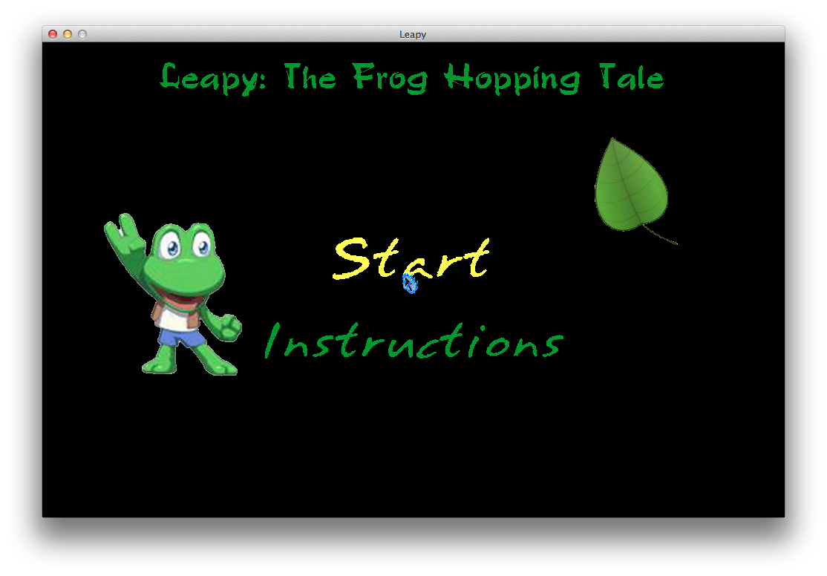**

Main Menu screen – instructions have not been added just yet. Friendly images displayed

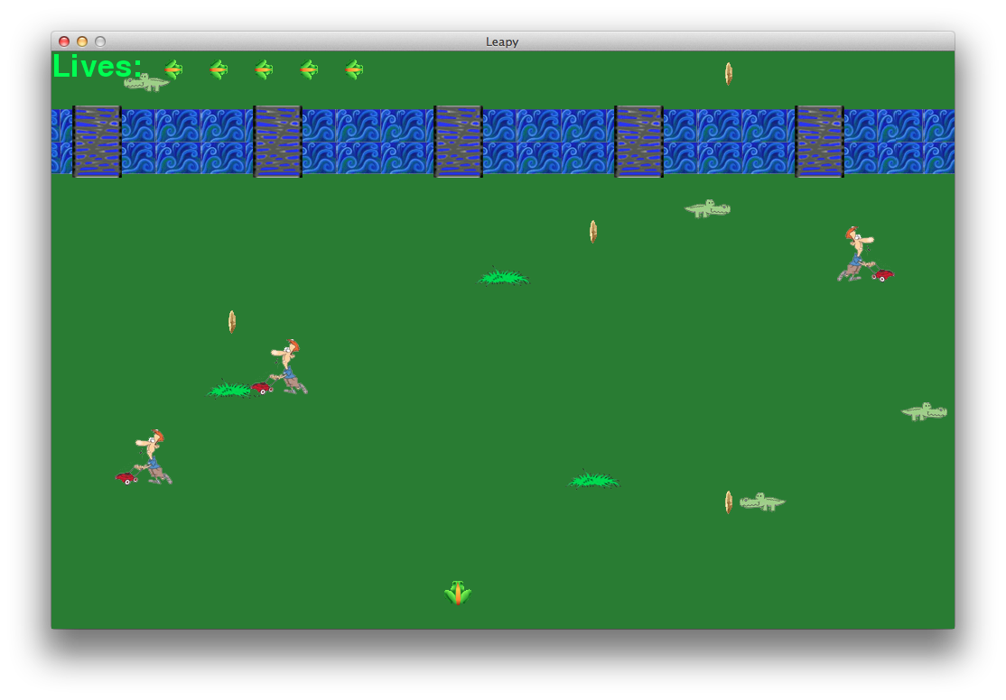

Level 1 – various alligators and pedestrians that Leapy must avoid while collecting the golden coins

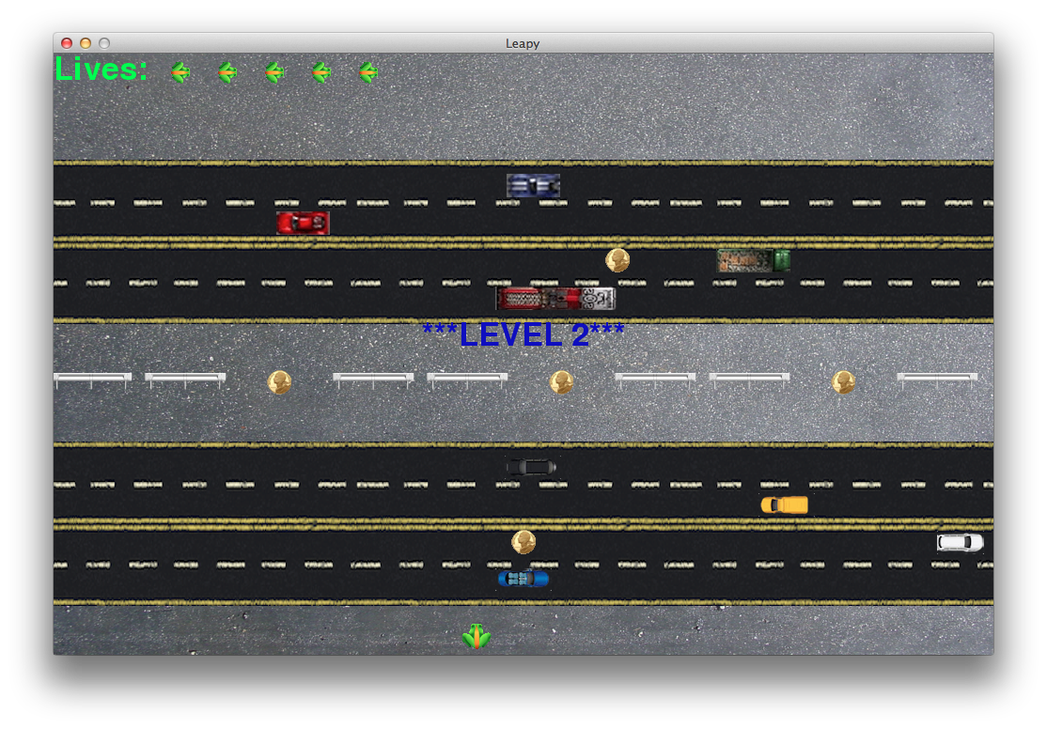

Level2 – with the fast cars whipping by, Leapy must cross the highway in order to get to all the coins and continue on his journey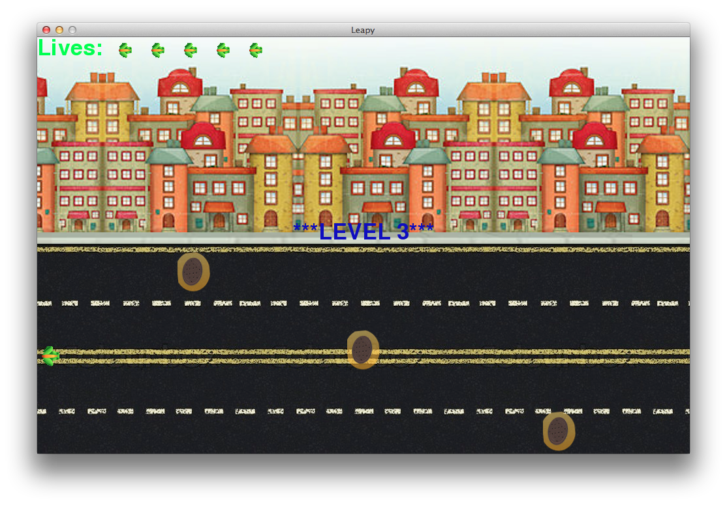

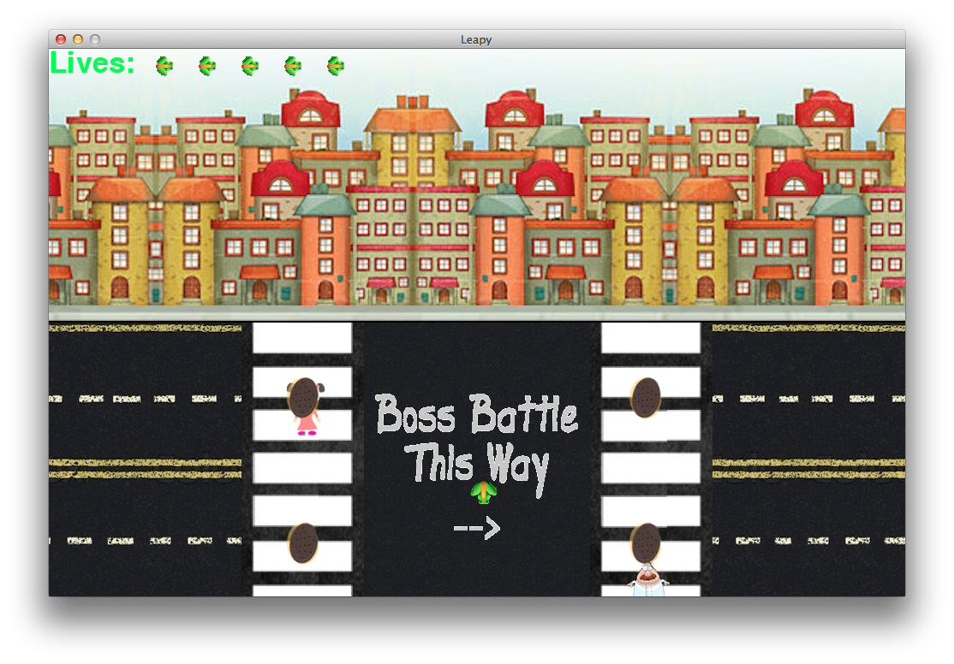

Level 3 – a couple screen shots to show the side-scrolling aspect of this level. Leapy must follow the street and collect the sewers while avoiding the pedestrians and on-coming traffic. The sewers may possibly hint at a theme for the boss battle?

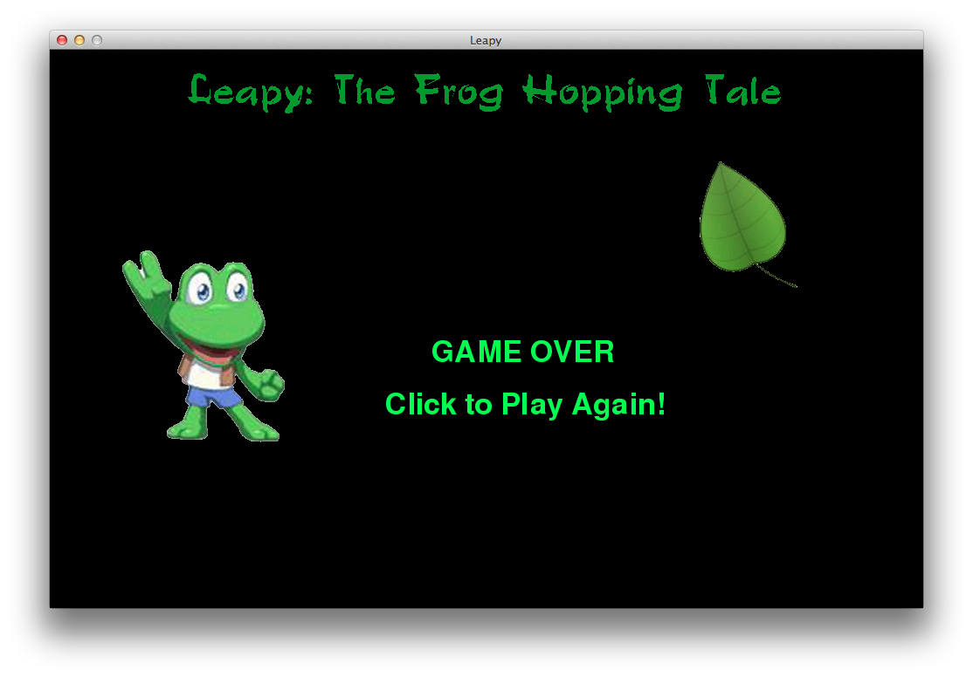

Game Over screen – and of course a game over screen asking he user if they had so much fun that they would like to play again.

1. **Levels**

There are various levels In Leapy. Level 1 is a forest/jungle themed level with alligators running across the screen and pedestrians cutting the grass. Leapy must avoid these at all costs while collecting the golden coins placed across the level. Level 2 is a highway themed level and with multiple cars going both directions at different speeds, Leapy must collect the coins and cross the highway safely in order to continue on. Level 3 is a city-based theme in which Leapy must now collect the Sewers place along the road while avoiding the on-coming traffic and some pedestrians crossing at the crosswalk. After the Sewers are collected Leapy must continue on this side-scroller level on to his first Boss Battle.

1. **Characters/Vehicles**

You play as Leapy, a frog who is on a journey across the world. On his journey he comes across multiple Enemies and must take them down in order to continue. What Leapy does not know, but soon finds out, is that he has super powers and these only come out when his survival instincts kick in.

1. **Enemies**

While Leapy is on his journey, he must avoid many obsticles such as pedestrians and vehicles in order to live. Every few levels, he encounters a Boss battle in which he must use his super powers to take down.

1. **Scoring**

Every level, there are a set amount of objects whether they be coins or sewers, and Leapy must collect all of these in order to continue on.

1. **Sound Index**

CoinCollect.ogg – when Leapy collects any objects within the level

FroggerJump.ogg – sound is played every time Leapy jumps

Horn.og – When Leapy gets hit by a car

Squish.ogg – When Leapy gets hit by pedestrians or other enemies

Splash.ogg – When Leapy takes a dive In the water

bgMusicLevel2.ogg – Background Music for level 2 and 3

bgMusic.ogg – Background Music for level 1

SonicMusicForFrogger.ogg – Background Music that plays for the full game

1. **Art/Multimedia Index**

 - chef used in level 3

-Macintosh HD:Users:owner:Documents:Georgian Work:PYTHON:Final Project - Part A:0.5:FroggerEnemies:FroggerGator0_Left.png alligator used in level 1

Macintosh HD:Users:owner:Documents:Georgian Work:PYTHON:Final Project - Part A:0.5:FroggerEnemies:Girl:girl - 1.png - little girl crossing the road in level 3

Macintosh HD:Users:owner:Documents:Georgian Work:PYTHON:Final Project - Part A:0.5:FroggerEnemies:LawnMower0_left.png- pedestrian cutting the grass in level 1

 - multiple and various cars much like this one used throughout all levels